INSPECTION/SERVICING BRAKE DRUM

It is recommended that the Synthetic Oil (Part #20405 Rml Oil) inside the Load Unit of the Model 200, Model 375, NEB 200, NEB 400, NEB 600 and the NEB 800 Ag PTO Dynamometers must be inspected every 50-100 hours to determine the condition of the oil. Normal coloration of the 405 Synthetic Oil (Part # 20405) should be a honey brown color with transparency.

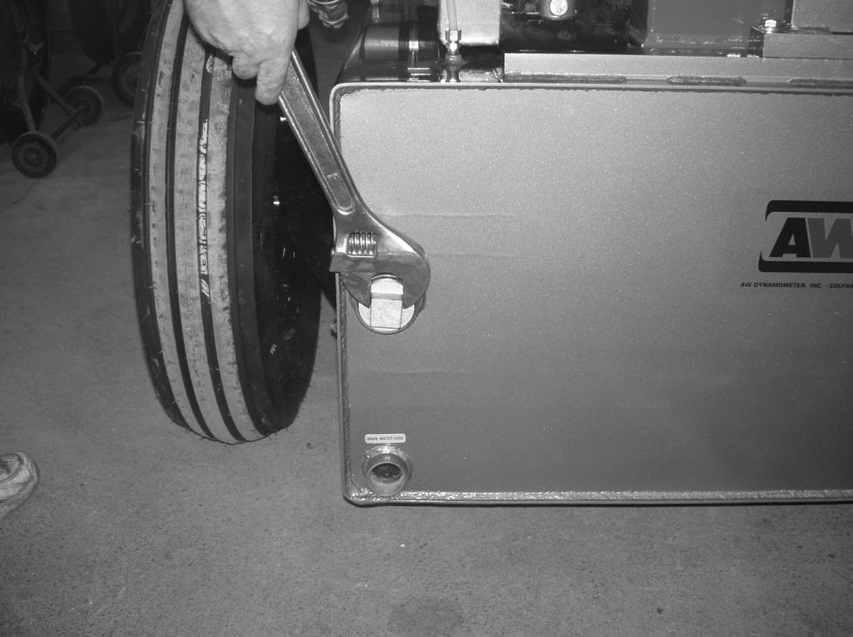

- Drain the water from the bottom base tank until the water level is below the brake drum.

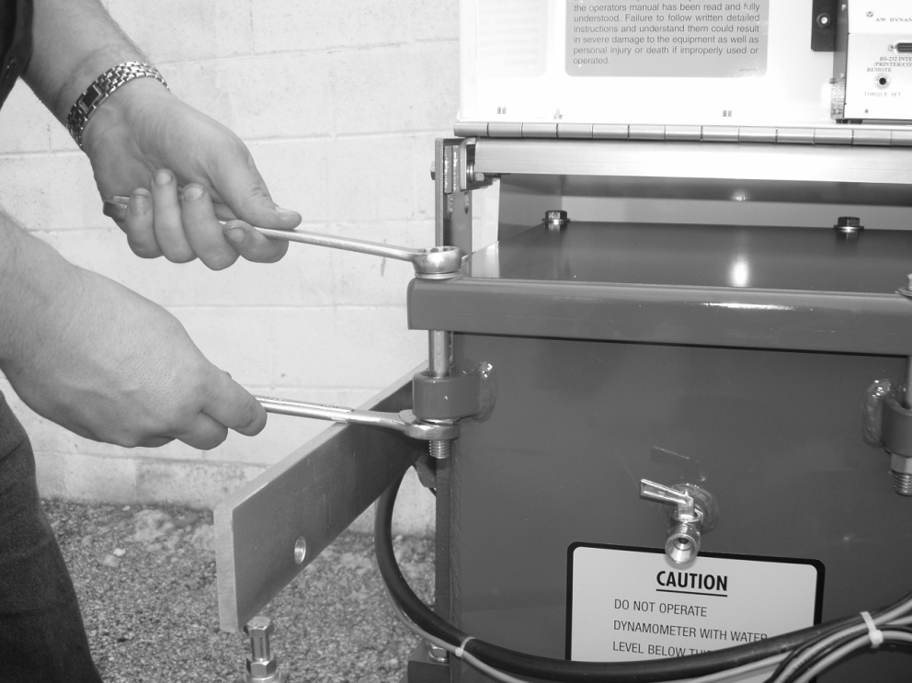

- Remove reservoir lid using two ¾ wrenchs.

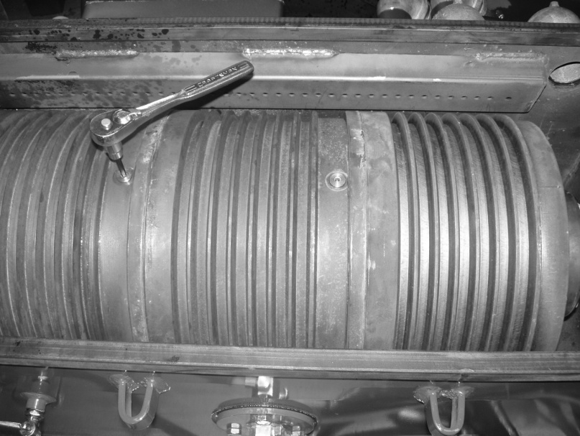

- Remove “O” ring plugs from brake drum(s).

- To inspect the 405 Rml Oil, rotate the drum(s) until the “O” ring plug holes are at the 7 o’clock position then quickly rotate the drum assembly back to the 12 o’clock position. During this process, there should be a residual amount of oil on the load unit assembly.

- If the Synthetic Oil is a honey brown color, then the fluid is satisfactory and does not need to be drained or replaced. *** If the 405 oil is black due to overheating of the drums caused by lack of water or exceeding the torque limitation, then follow procedure #6 below.

- To drain all of the 405 oil, rotate the drums until the “O” ring holes are on bottom at the 6 o’clock position. Continue to drain for 5-10 minutes.

- Rotate the load unit until the “O” ring holes are at the 12 o’clock position.

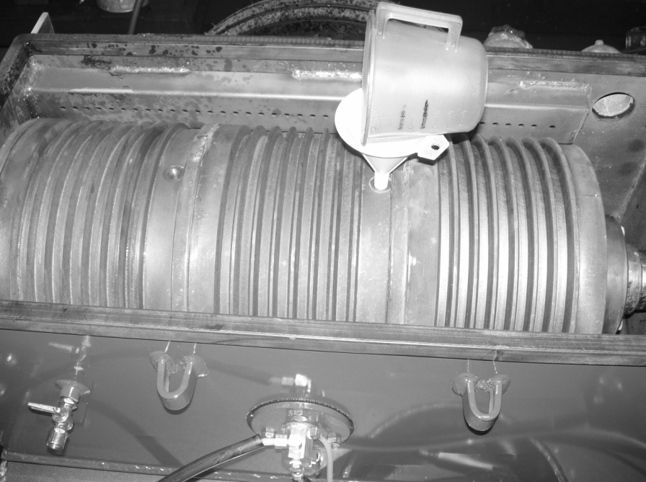

- Replenish 1 pint (.24 l) of 16 ounces of 405 Rml synthetic oil per drum.

- Insert and tighten the plugs.

- Attach the dynamometer to the PTO of the tractor. Before engaging the tractor, make sure the operator has an electronic heat gun to detect the heat inside the drum. Do not exceed 140 degree F inside the drum.

- NOTE: No water is used during flushing cycle.

- Start the tractor and spin the PTO @ 500-600 Rpm’s for 5-10 minutes.

- Disengage PTO and stop the tractor engine.

- Begin to drain the oil from the brake drum(s). (5-10) minutes.

NOTE: If oil appears extremely dirty or dark, a second flushing is recommended. Dark oil indicates extreme heat due to lack of water or passing the torque limitation on the dyno.

- If the oil appears transparent and has a honey brown color it is successful and you can continue the draining of the brake drum 5-10 minutes. Replenish each individual brake drum with 6-8 ounces of new Rml 405. Fasten “O” ring hole snug tight.

- Replace the reservoir lid and fill with water. *** Make sure the tightening of the lid was hand tight and not down with an air ratchet. Over tightening the lid gasket will cause it to split and will not seal.

